# **Hub**

Data packet is arriving at a node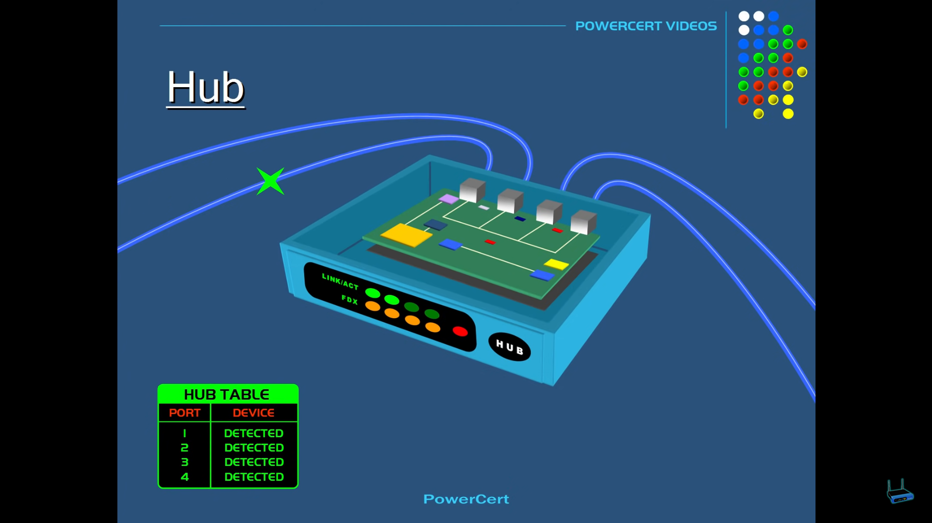

That data is copied to all-other devices in that hub.  
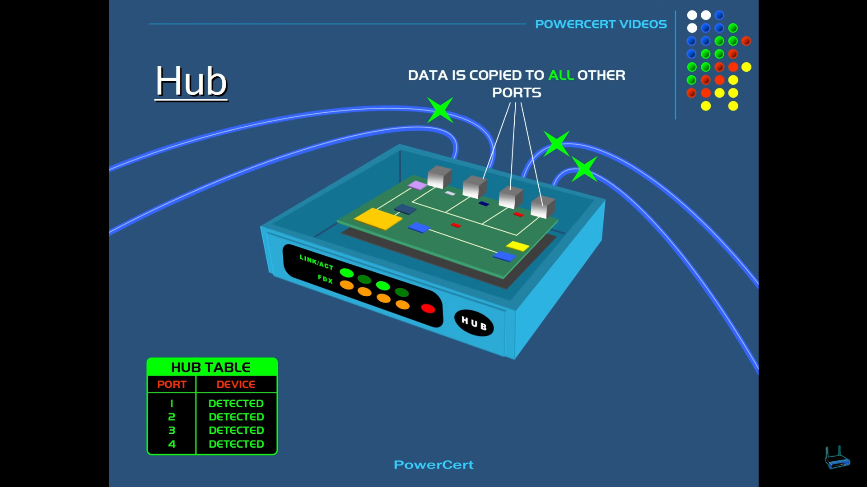

Real world example

Except the source and destination all other computers on that hub will receive that packet which is un-necessary.  
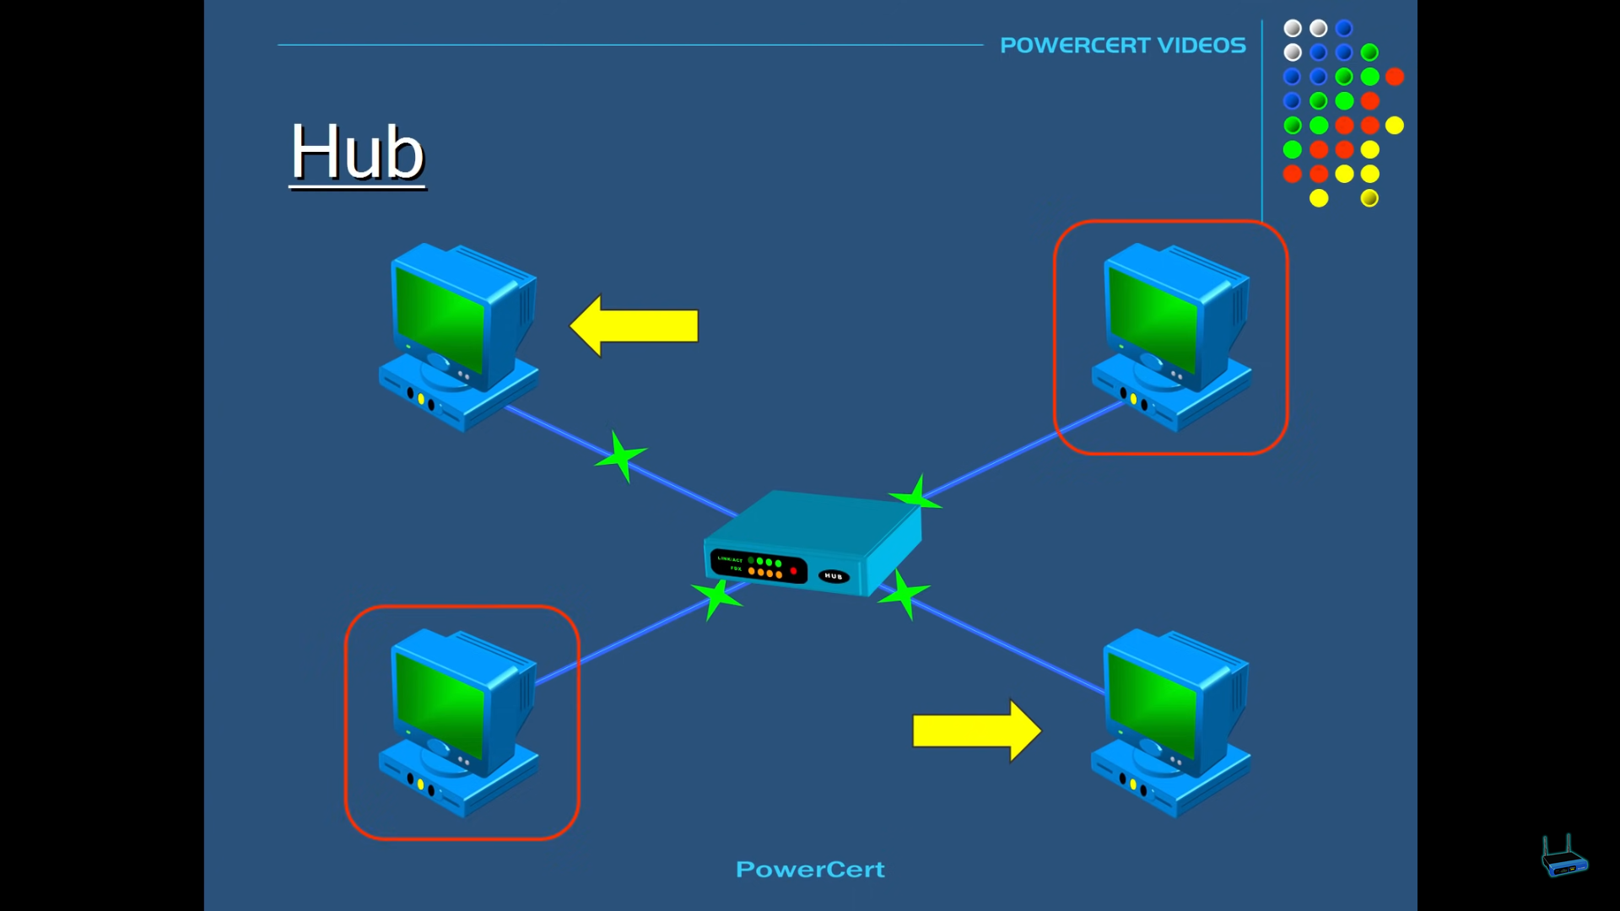

Wastage of bandwidth.

# **Switch**

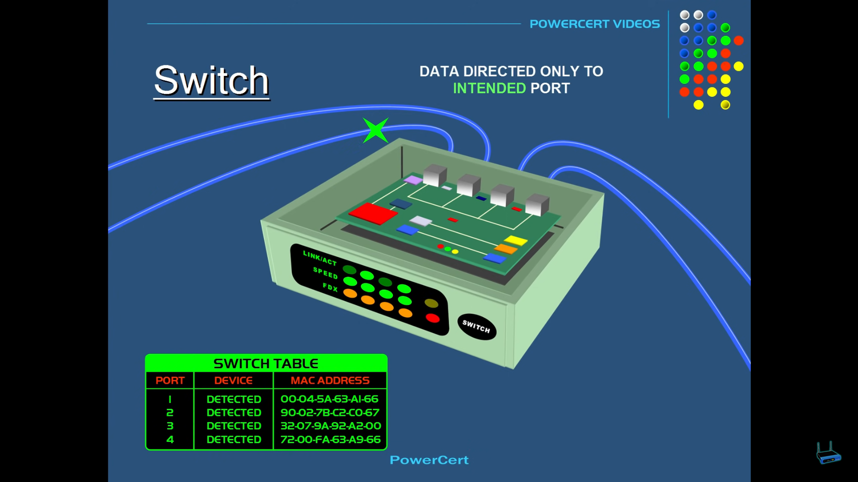

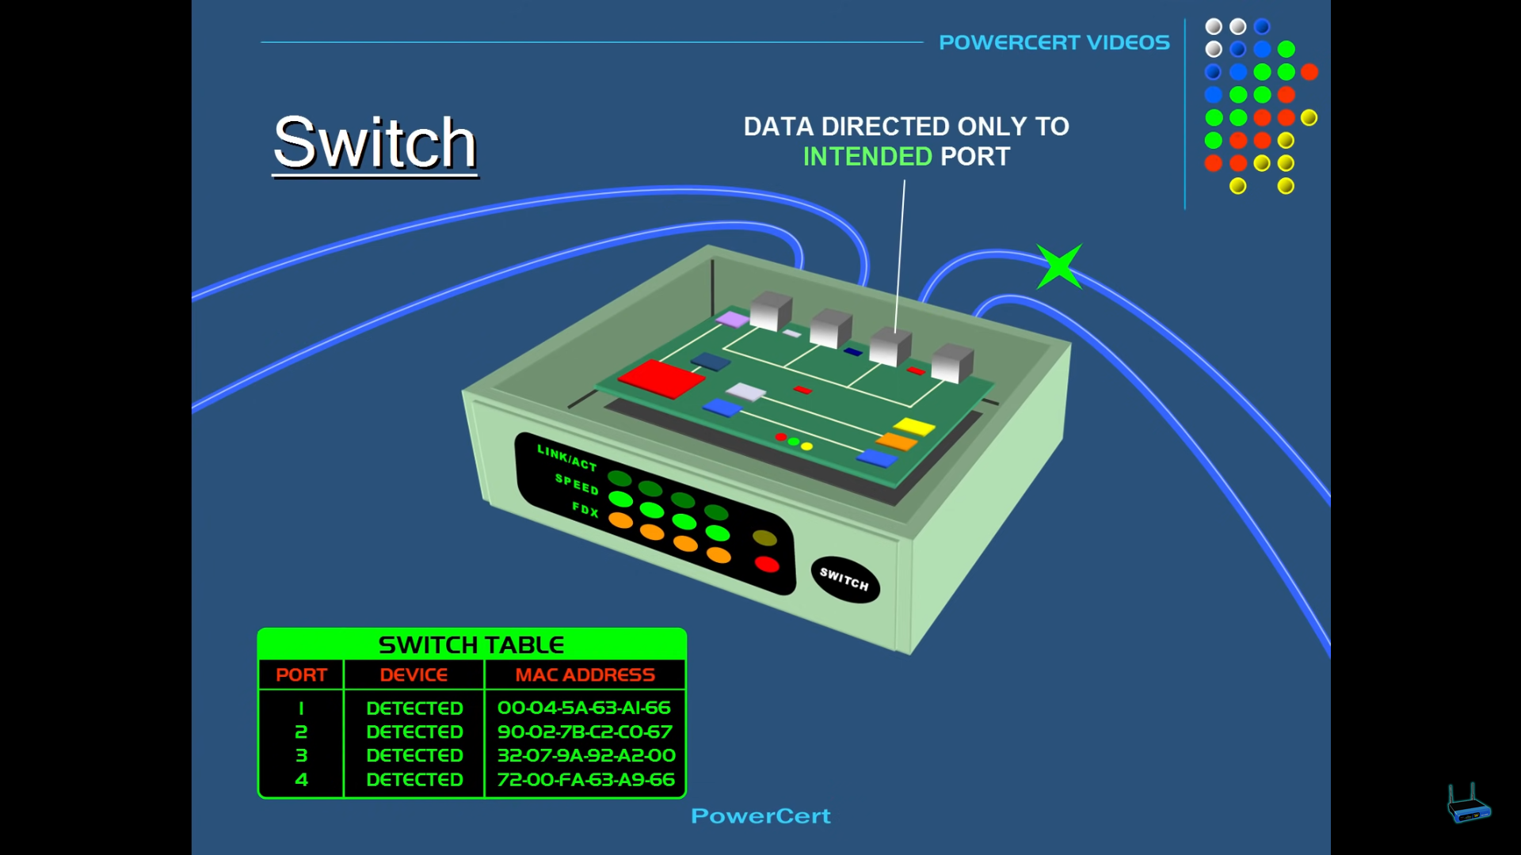

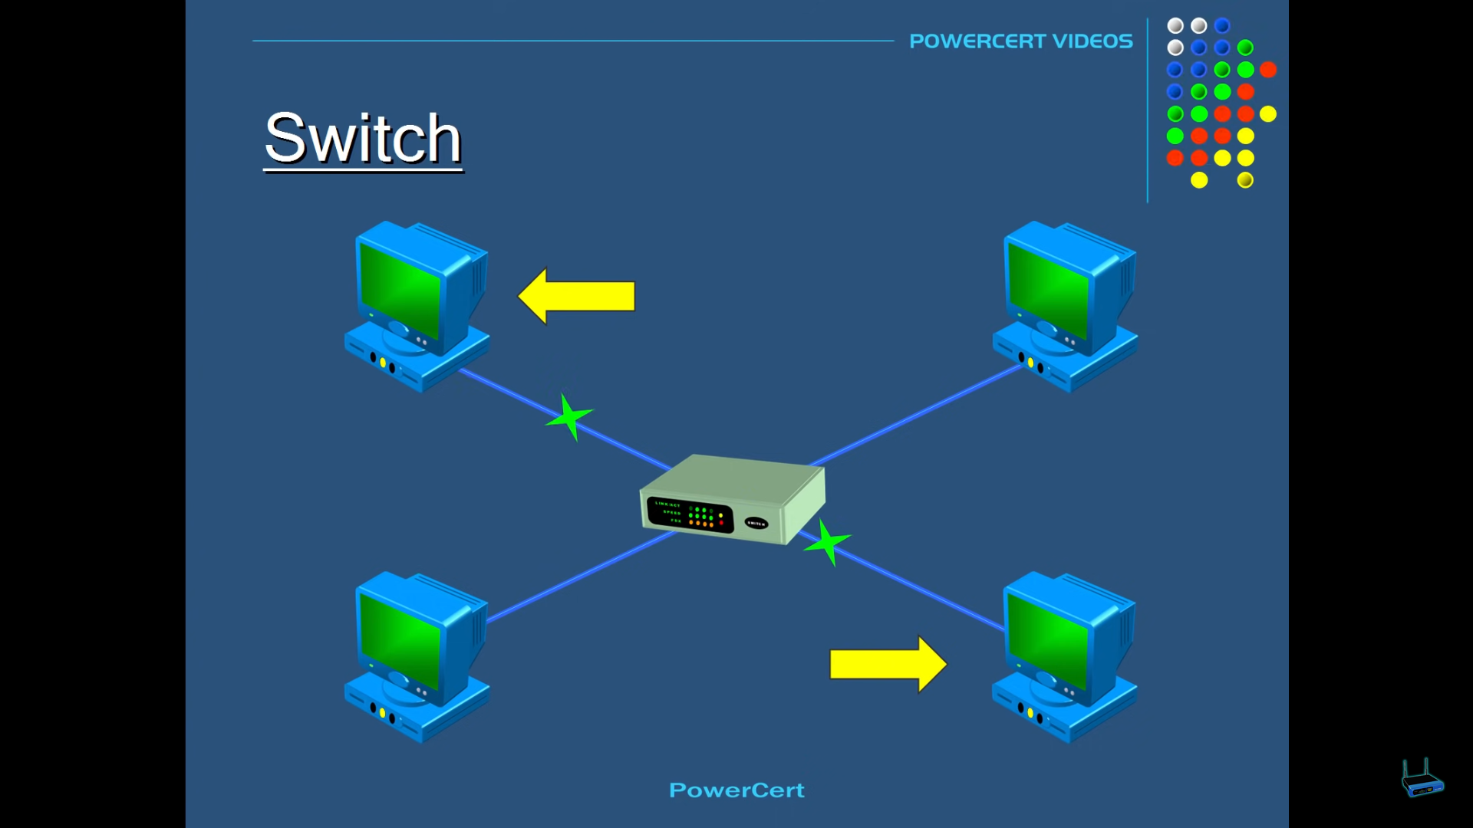

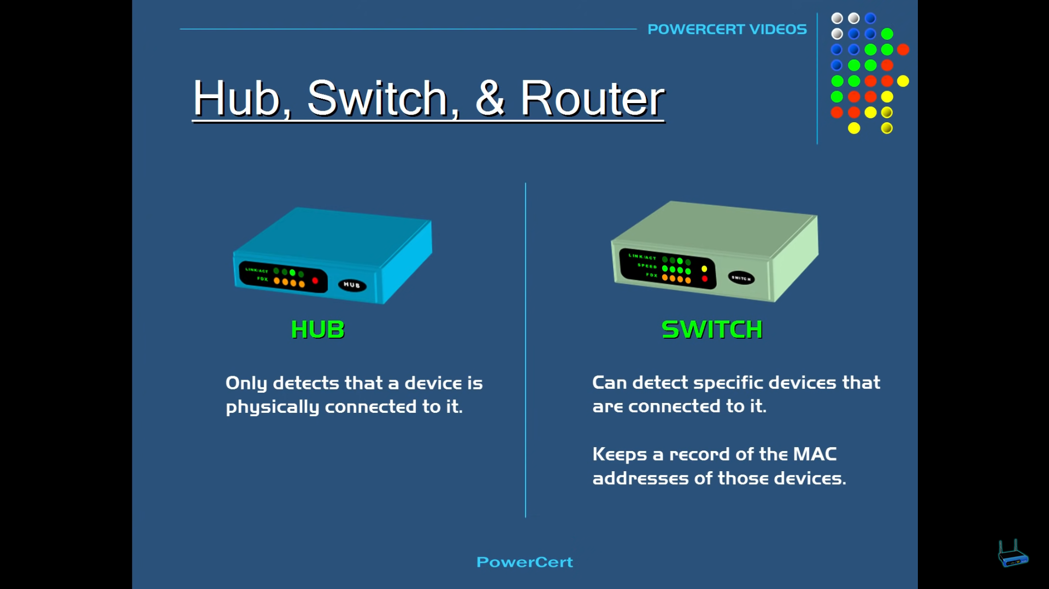

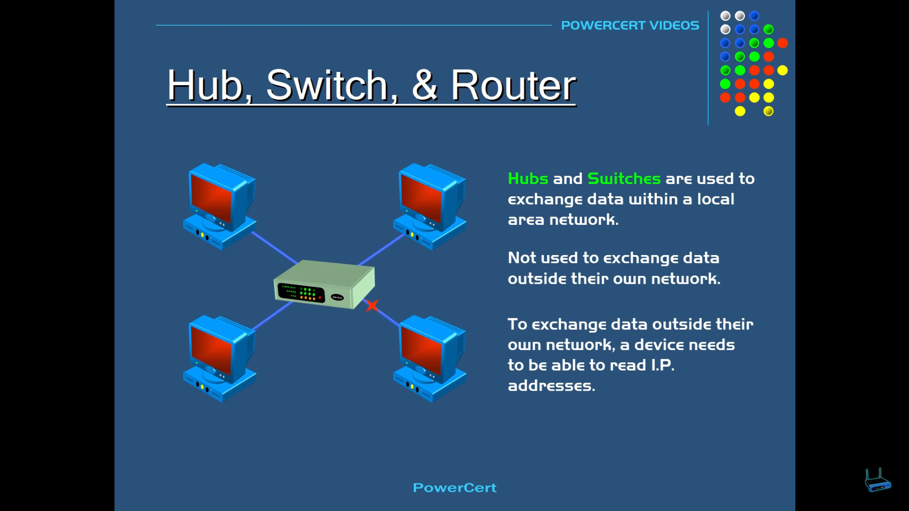

Hubs and Switches cannot able to communicate with the devices outside the network.

# **Router**

Router is essentially a gateway of a network.

A router is a devices which routes/forwards the data from one network to the another network based on their IP addresses.

Need for a router

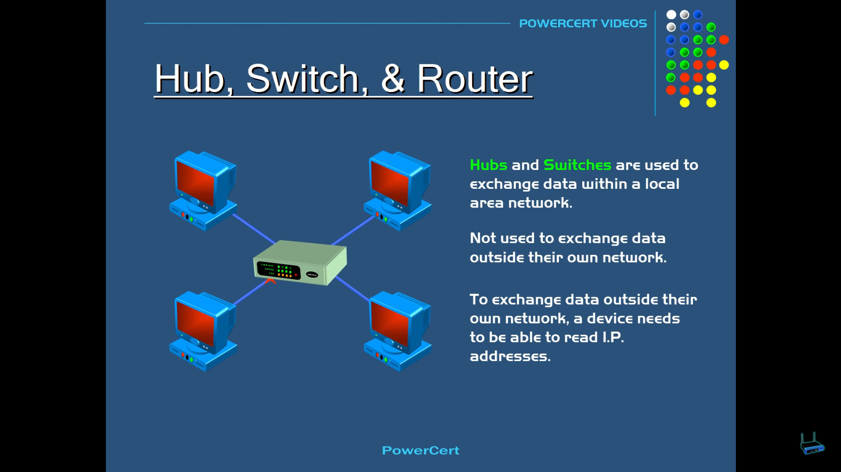

# **Difference between Modem vs Router**

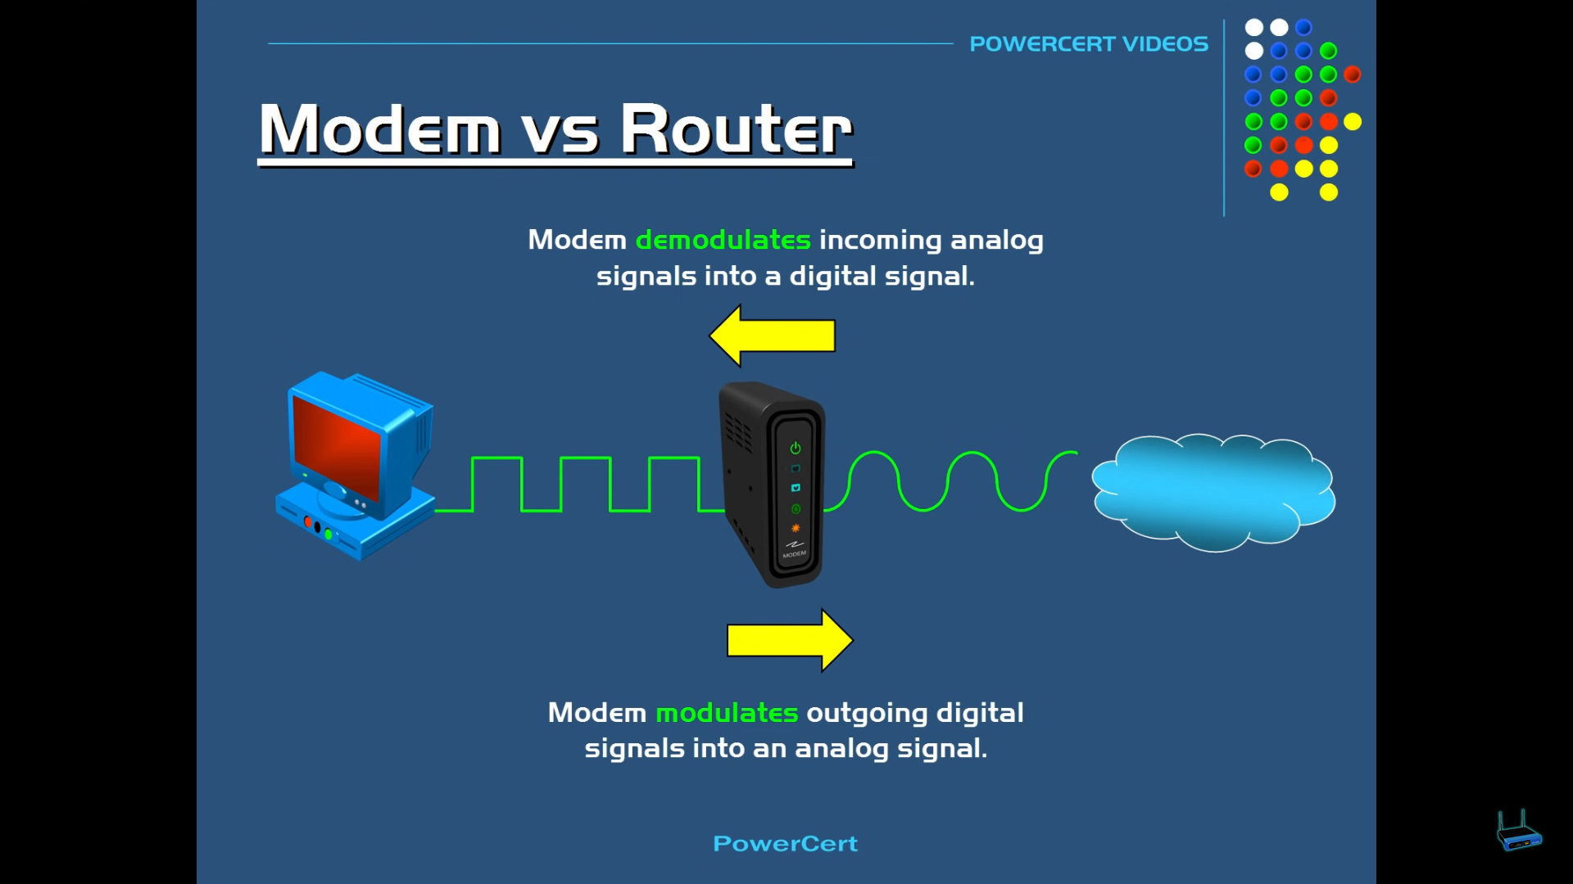

Modem 🡪 modulator and demodulator  
modulates the outgoing data from the computer.  
demodulates the incoming data from the internet.

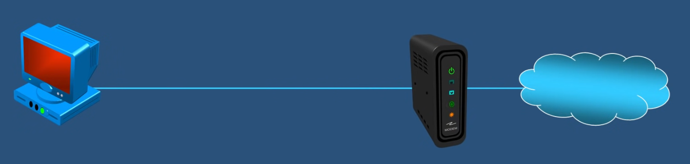Single PC can be directly connected to the modem it-self, there is no need of a router.

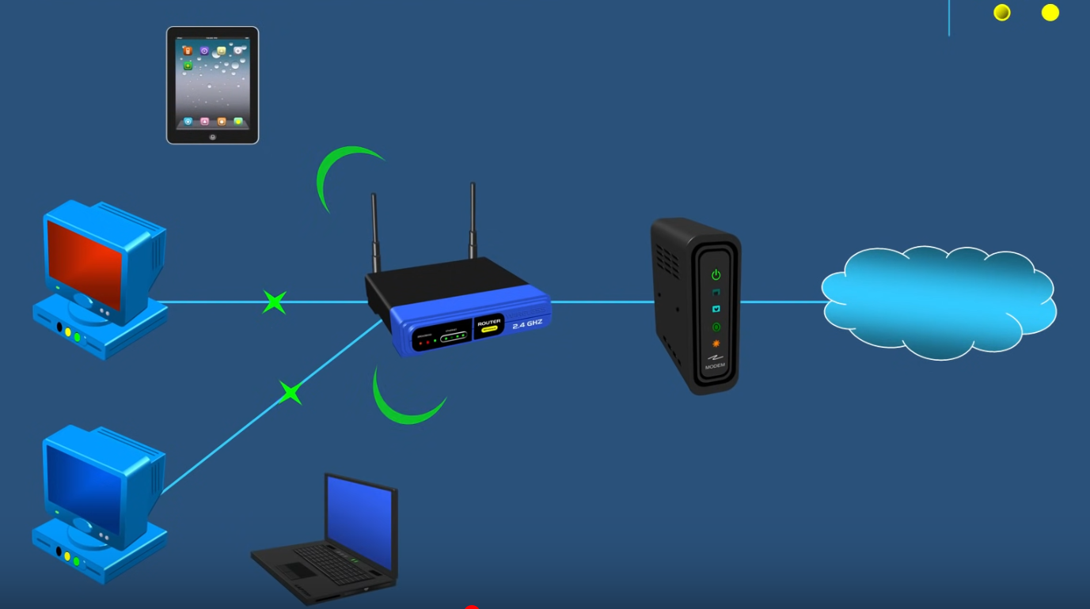  
If many PC’s tablets, mobile phones are there, router can be used.

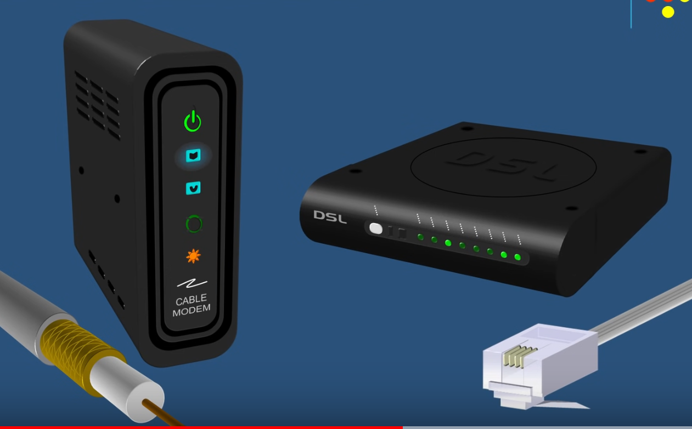Cable modems are connected to the houses using co-axial cable. (Comcast)  
DSL modems are connected to the houses via typical phone lines. (AT & T)

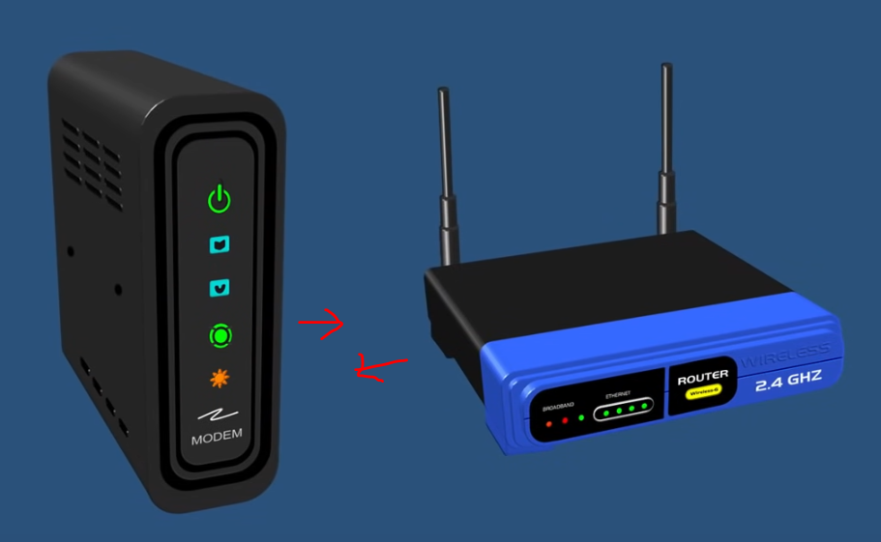 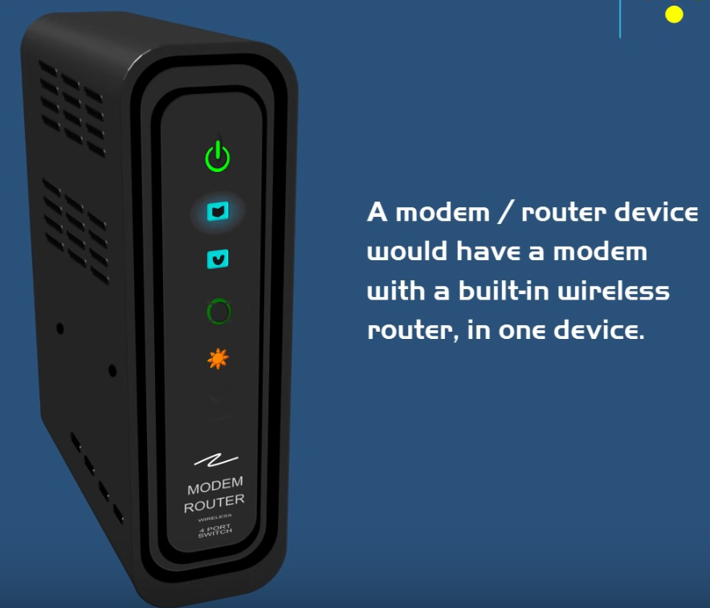  
During the actual purchase there will be no separate device it will be in a modem, router combination.



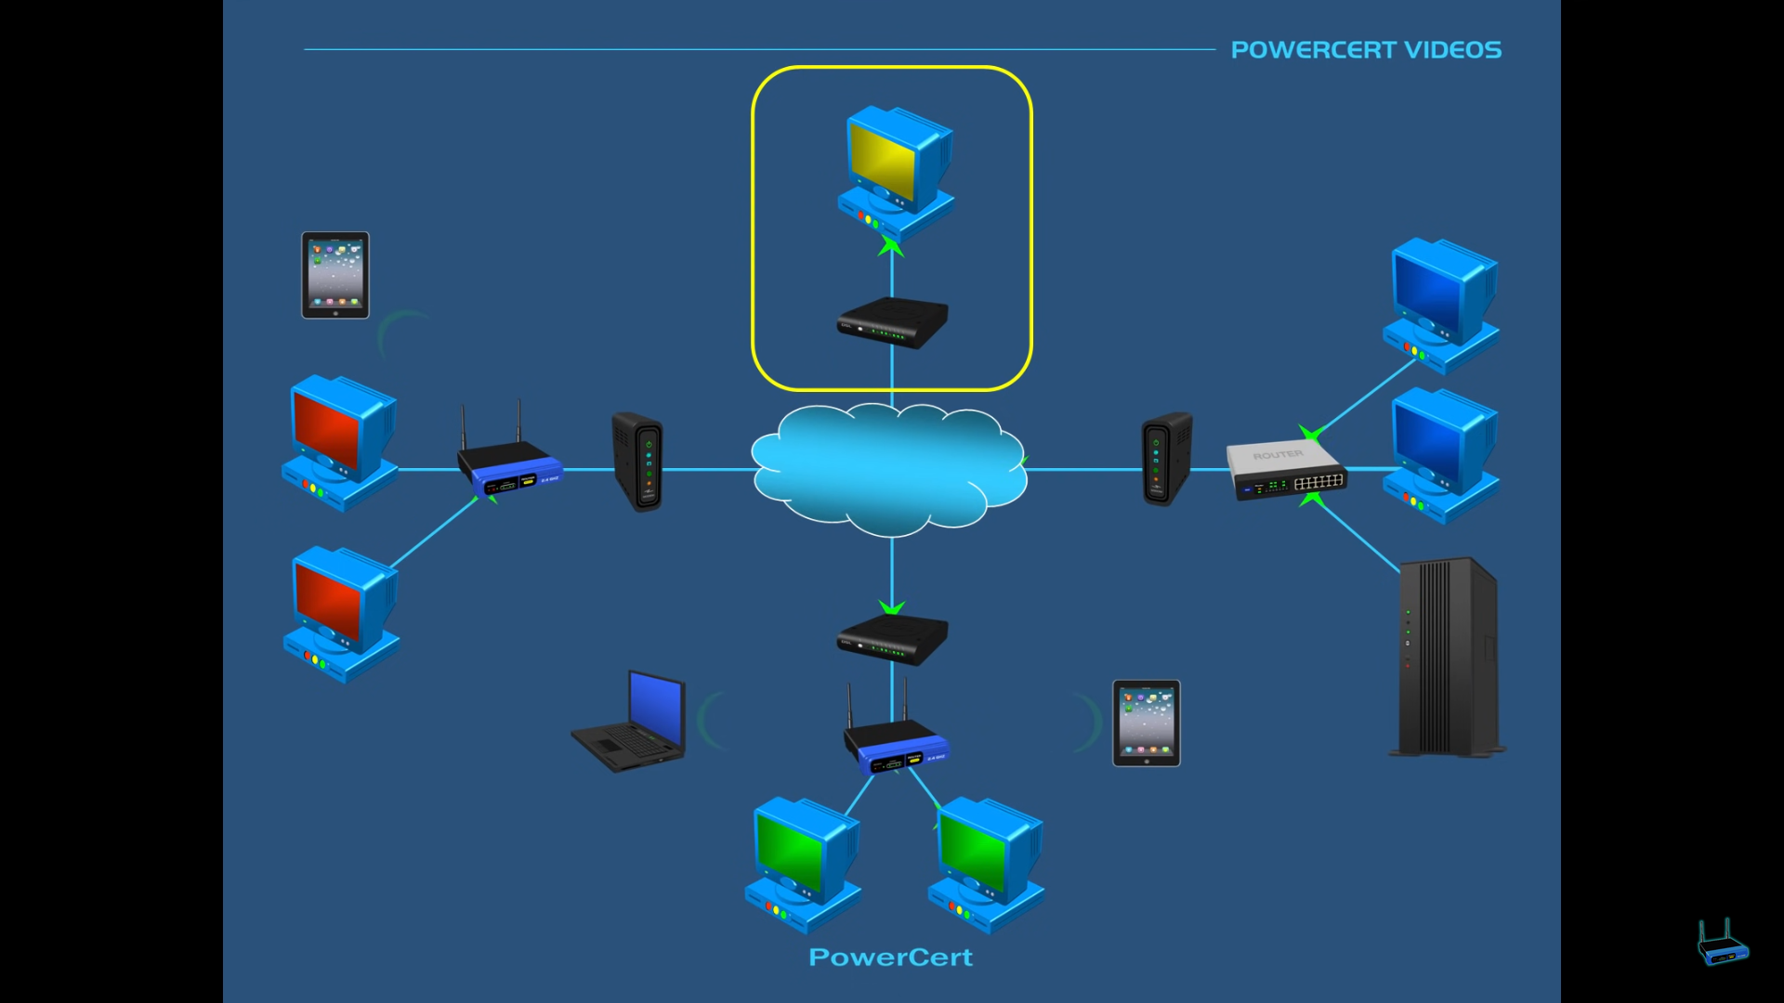

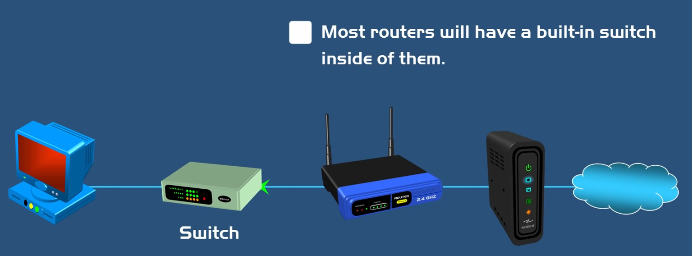  
Most routers are having built in switches so there is no need of an external switch.

Eg: a router having 4 ports connected to it, and you are having 6 PC’s to connect.  
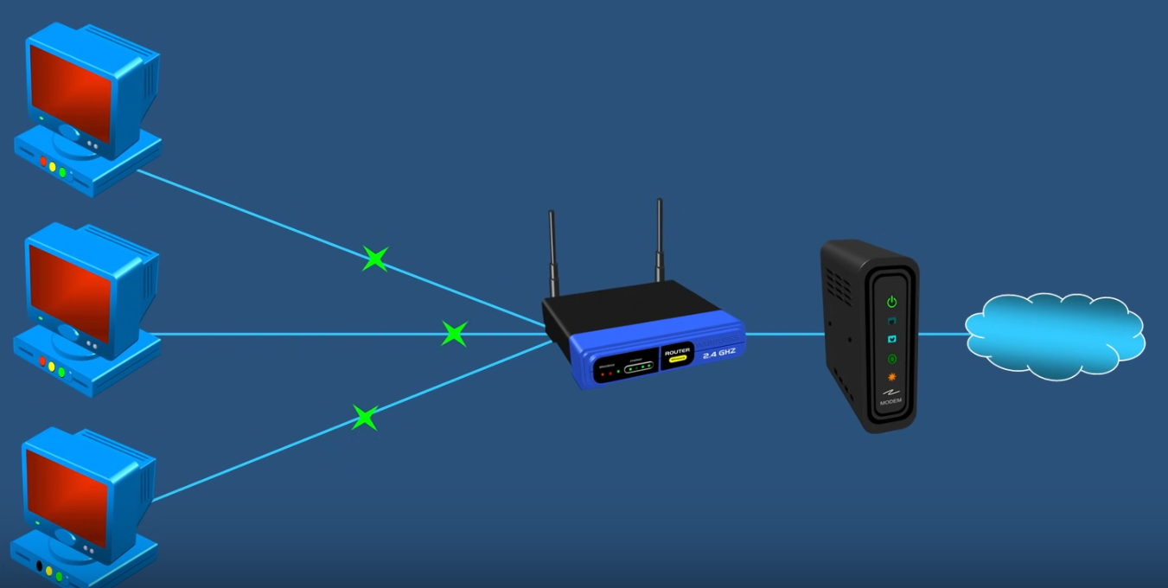  
First 3 PC’s are connected directly to the router and uses the in-built switch.  
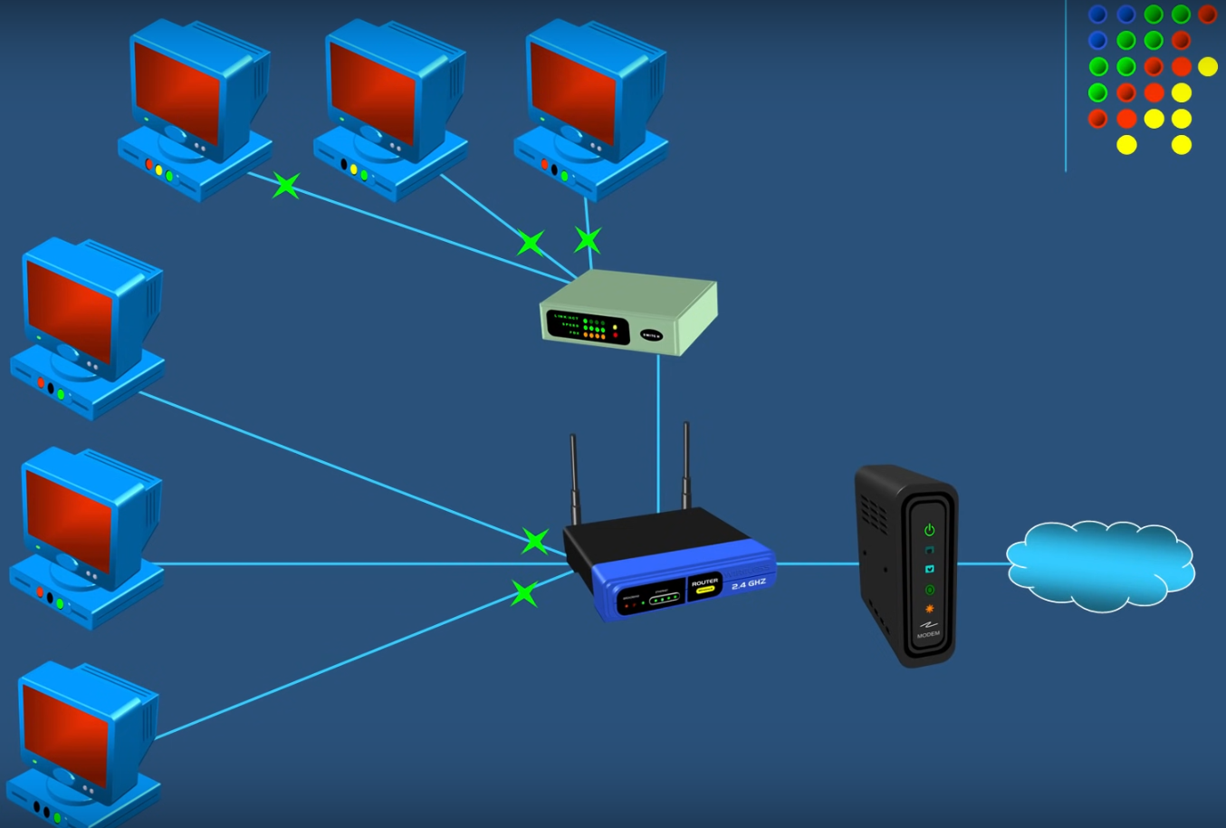  
4th port is used for the switch, then the remaining 3 PC’s are connected to it.

Real world scenario  
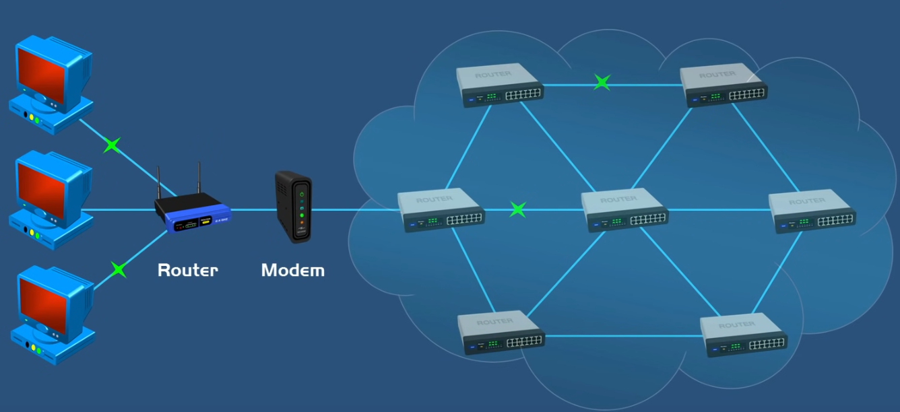

References

<https://www.youtube.com/watch?v=1z0ULvg_pW8>  
<https://www.youtube.com/watch?v=Mad4kQ5835Y&t=89s>